**Using the AMS: Language Editor**

1. Load up the editor by double-clicking the Language Editor.exe
2. Select your language choice from the ‘Editing:’ combo box:

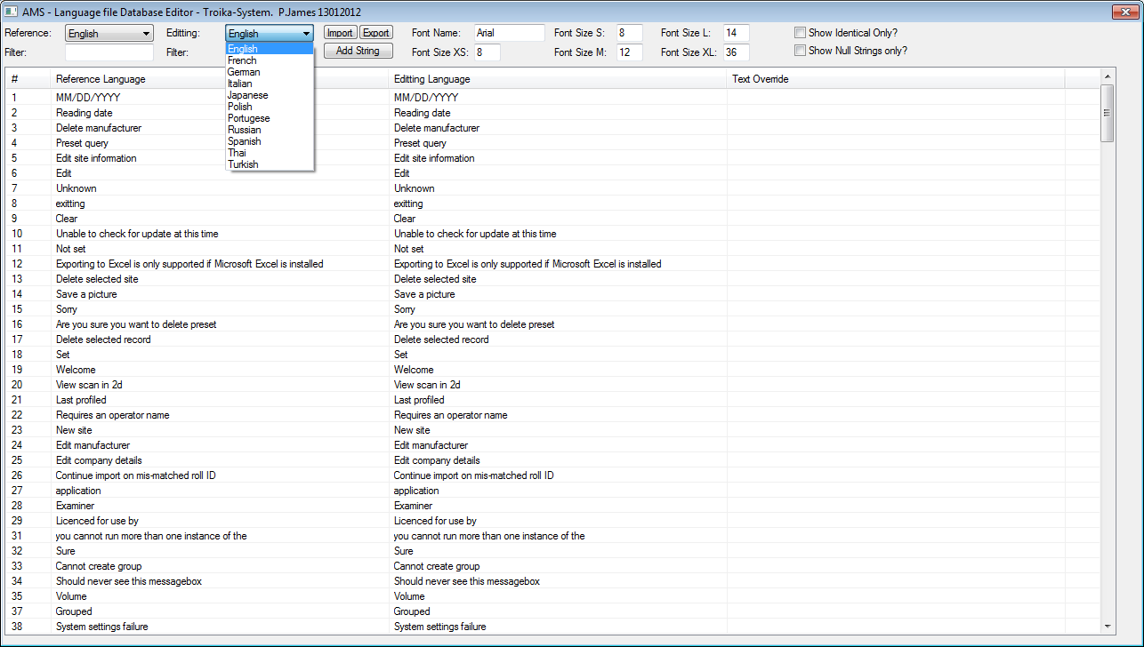

1. Double click any entry that requires editing, the override request will pop up with the original text, overwrite this with the required text, then click on ‘OK’

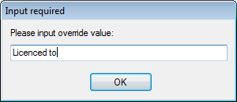

1. The edited string will now have an ‘Override’ entry next to it, which will be used in place of the original text in the AMS application. The database is updated automatically.
2. Repeat Steps 3 & 4 until all required strings are translated.